**Bryozoa (moss animals) are colonial lophophorates.** Colonies are composed of individuals, or zooids, which are usually less than 0.5 mm in length. Each zooid inhabits a secreted box, the zooecium, into which is can retract. Because of their small size, hemal, excretory, and respiratory systems are absent.

Colonies are usually attached to firm substrata and may be encrusting layers a single zooid thick, or more leaflike (bushy) and branching. Bryozoans often resemble seaweeds (or mosses) with which they are frequently confused by the public.

.

**1. External Anatomy of a typical bryozoan**.

**Colony Morphology**

Place a section of the colony of *Bugula or other species available,* in a finger bowl of seawater. Do not leave the rest of the colonies without water, and do keep the colony you are transferring in water. Add sea water so that your smaller bowl is almost full of water. Place the dish on the stage of the dissecting microscope and begin your observations with low power.

a. **Examine the colony for organisms that are using the bryozoan colony as substratum. What animals do you see? Obtain photographs of some of these inhabitants.**

The colony itself is composed of branching stems . The central stem of the bush is attached firmly to some hard substratum (in life). The colony is made of large numbers of typical feeding zooids called **autozooids**. There may also be a variety of specialized zooids, known as heterozooids, modified for functions other than feeding. Before examining the internal anatomy, add some fine suspension food to your colony. Phytoplanton or micro verts, (not the larger macro vert food), and try to focus on some autozooids on high power to see them feed.

**b. Film autozooids moving in and out of their case and feeding if you can if you can. Can you see the cilia on their lophophores? The direction of water flow should be evident**

Heterozooids

Look for heterozooids or zooids that are modified for other functions besides feeding, with high power of the dissecting microscope. Many autozooids bear hemispherical ovicells, or ooecia, at their distal, or free, ends **. Ooecia are highly modified heterozooids which serve as brood chambers for the adjacent autozooid.** A single egg is brooded in each ooecium**. Look for embryos in the ooecia. Colonies may be shedding larvae. They look like fast moving brown balls. Examine these later under the light microscope.**

Some *Bugula* species have **avicularia**. These are defensive heterozooids shaped like the head of a diminutive raptorial bird . Avicularia are specialized for discouraging predation and settling by the larvae of fouling organisms. They are attached to the sides of the autozooids and have a pair of mandibles to pinch predators or larvae. If our colonies do not have them, (I forgot to look) **look at the old pics of bryozoans from the first Cnidaria lab or do a web search for suitable pictures as those below.** Note the large bulbous "cranium" with fixed upper and movable lower mandibles. The cranium is the zooecium of the heterozooid whereas the movable lower mandible is its operculum. **Try to find some pictures of open and some closed avicularia.**

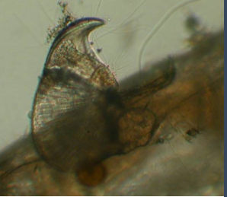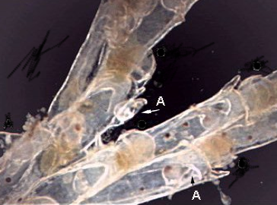

**2. Internal anatomy of a bryozoan. Now you are ready to examine individual zooids under the light microscope. Cut off a small branch of the colony and place on a depression or regular slide. Examine feeding and the internal structures of an autozooid under low power of the light microscope.** The youngest and most transparent zooids are at and near the free tips of the branches. The stems and bases of the branches consist largely of another type of heterozooid known as kenozooids. In *Bugula* the kenozooids are simply the empty zooecia of dead autozooids but, although dead, they continue to be important structurally in anchoring the colony to the substratum.

As you watch suspended particles in the water near the lophophore, note how they move with respect to the lophophore. Do the particles enter by passing between the tentacles or do they come in through the open base of the funnel and exit between the tentacles? Watch for motion of the tentacles, especially the characteristic "flicking" of bryozoan tentacles. What effect does the flicking have on particles?

At highest power take 4-5 photographs of internal anatomy. You will be labeling these photographs later in the course.